Operation on a number line
Addition
Add 2 and 5. i.e 2 + 5
Start from 0, 2 jumps towards right. You reach at 2.
Start from 2, 5 jumps towards right. You reach at 7.
Therefore, 2 + 5 = 7
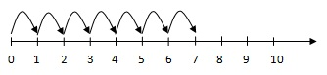
Subtraction
Subtract 4 from 7. i.e 7 - 4
Start from 0, jump directly to 7.
Start from 7, 4 jumps towards left. You reach at 3.
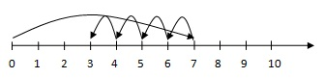
Multiplication
Example i.e 3 x 2
Multiplication means repeated addition. Since 3 x 2 means 3 added twice.
Start from 0. Make 2 jumps (each jump of 3 units).You reach at 6.
